Introduction

In this technical note, the MATLAB control toolbox was used to design a simple control system for controlling the steady-state error of an open loop system. Bode-plots, step response and pole-zero locations were simulated to design the steady-state error of a feedback control system.

Proportional and Derivative Control
E(s)
+
-
G_{(s)}
k₁+k₂s

The transfer function of the open-loop system G(s) is given by
$$G_{(s)}=\frac{1}{(1+{\text{sT}}_{1})(1+{\text{sT}}_{2})}$$

If T₁=1 and T₂=0.1, the root of this system are –1 and 10. This can be converted to a polynomial form by typing pp=poly([-1 –10]) and the tranfer function of the open-loop system therefore is:

$$G_{(s)}=\frac{1}{(1+s)(1+0\text{.}1s)}$$
$$=\frac{1}{0\text{.}1s^{2}+1\text{.}1s+1}$$
$$=\frac{1}{s^{2}+\text{11}s+\text{10}}$$

The closed loop transfer function H(s) can be derived as below,

$Y_{(s)}=E_{(s)}G_{(s)}$ where $E_{(s)}=x_{(s)}−(k_{1}+k_{2}s)Y_{(s)}$
$$Y_{(s)}+Y_{(s)}G_{(s)}(k_{2}s+k_{1})=x_{(s)}G_{(s)}$$
$$Y_{(s)}[1+(k_{1}+k_{2}s)G_{(s)}]=x_{(s)}G_{(s)}$$
$$\frac{Y_{(s)}}{x_{(s)}}=\frac{G_{(s)}}{1+G_{(s)}(k_{2}s+k_{1})}=\frac{\frac{\text{10}}{s^{2}+\text{11}s+\text{10}}}{1+\left(\frac{\text{10}}{s^{2}\text{11}s+\text{10}}\right)\left(k_{1}+k_{2}s\right)}$$
$$H_{(s)}=\frac{\text{10}}{s^{2}+\text{11}s+(\text{10}(k_{1}+k_{2}s))}$$

Proportional Control

In order to analysis the behaviour of proportional control, different values of k₁ were chosen within the range 1-100 and k₂ was kept at zero.
k₁=(1, 2, 10, 20, 50, 80, 100)

The Effect of proportional control

Step Response

From the graph 2, it indicates that when k₁ is greater than zero and less than two, the step response grows gradually until it reaches a particular level with no oscillation. The level it has reached is the stability of the system. However, as k₁ increases further, the step response increases gradually at first, then it oscillates rapidly until it go to a steady state at particular level. From the graph 2, it is clear that the higher value of k₁, the shorter time the system to reach its steady state. But it also causes longer oscillation, so its steady stay error is higher.

Bode Diagram

In a bode diagram (graph 1), when k₁ is less than 10, the curve does not have a “peak”, it gradually decreases until it reach its minimum points. As k₁ keeps increasing, a “peak” is formed and keeps increasing and shifts to the right hand side in the graph as shown in graph 1. For all values of k₁, the curve has the final gradient –20dB/decade. Compared with the step diagram (graph 2) and the bode plot (graph 1), there is a pattern that if the “peak” has a higher height, the higher the amplitude of the step response has. Similarly, like bode diagram (graph 1) and a s-plane, the magnitude of the response at the particular frequency in the bode plot is correspond to the distance between the poles of the imaginary components in s-plane. Since as k₁ increases, the “peak” in the bode diagram shifts to the right, the imaginary components in the s-plane increases. From the phase diagram, as k₁ increases, the curves drop more and more rapidly from 0⁰ to -180⁰.

Poles and zeros

From a s-plane, the behaviour of the system can be easily to observe. The poles indicate the stability of the system and the decay rate while the zeros do not. From the table 1, it can be noticed that the poles are getting close to –5.5 on the x-axis when the k₁ is less than 10 and greater than zero. The poles do not have imaginary components and they lie on the real axis. As k₁ increases and greater than 10, for all poles, it has imaginary and real component. As k₁ increases, the poles with positive imaginary component increase and the real component keeps constant.

Value of K1 | Position of poles
1 | -2.3, -8.7
2 | -5.8, -4.8
10 | -5.5+9.8j, -5.5-9.8j
20 | -5.5+13.4j, -5.5-13.4j
50 | -5.5+21.9j, -5.5-21.9j
80 | -5.5+28j, -5.5-28j
100 | -5.5+32j, -5.5-32j
Table 1: the values of poles when k₁ is varied

The characteristics of the k₁=81/40, k₁< 81/40, k₁>81/40

Substituting k₁= 81/40 in the transfer function H(s) which has derived before and it gives:

$$H_{(s)}=\frac{\text{10}}{s^{2}+\text{11}s+\text{10}+\text{10}k_{1}+\text{10}k_{2}s}$$

But k₁ = 81/40 and k₂ = 0, so

$$H_{(s)}=\frac{\text{10}}{(s+5\text{.}5)^{2}}$$
For $H_{(s)}→∞$,
s = -5.5

From figure 1 and the calculation as shown above, when k₁ equals to 81/40, the poles are repeated at –5.5. In graph 2, it shows that when k₁ less than 81/40, the step response takes more time to reach its steady state. On the other hand, as k₁ greater than 81/40, the step response has more oscillation transient than k₁= 81/40, although the time to reach its steady state is faster. Hence, it proves that at k₁ equals to 81/40, it has the fastest response to reach its steady state without having oscillatory transient and this is called critically damped.

To conclude, k₁ is the value to determine the proportional control. When k₁ is less than 81/40, the poles on the s-plane lie on the real axis and tend to near the point –5.5 as k₁ increases. In this condition, there are no transient oscillations in step response due to the fact that no imaginary components and the system reach its steady in fastest response. When k₁ increases, the time to reach the steady state becomes faster but the steady state error becomes larger.

When k₁ greater than 81/40, the poles have the same values of real components which is at –5.5. However the imaginary component varies and gives rise to the amplitude of the step response as k₁ increases. This means that when there are imaginary components, the step response will decay exponentially toward its particular stability level. The system is said to be unstable. The larger the magnitude of the positive imaginary component, the higher the frequency of the oscillation and the faster it will reach its steady state.

When k₁ is equal to 81/40, the poles are both lie on –5.5 on the real axis with no imaginary components. No oscillation occurs on the step response. This shows that when k₁ is equal to 81/40, the system reaches its steady state in fastest response and without oscillation occurs. In this matter, the system is said to be critically stable.

The theoretical value of k₁ at 10Hz and 5Hz

As k₁= 400, the bode diagram 7 has a single peak close to 10Hz, and the poles are –5.5+ 63.085i and –5.5-63.085i. To get theoretical value of k₁ such that the peak was obtained at exactly 10Hz, following calculated has been done.

Equating the denominator, the following equations can be derived:

s²+11s+10(1+k₁)=(-5.5+62.8j)(-5.5-62.8i)
Then,
s²+11s+10(1+k₁) = s²+11s+3974.1

The imaginary part above is equal to 62.8rad/sec, so the answer of k₁ is equal to 396.41.

Compared with the graph 3 and 4, the “peak” in the bode diagram at the particular frequency corresponds to the frequency of the oscillations in the step response. For instance, in the graph 4, the frequency is at 5Hz and this is as same as the graph 3 when the “peak” is at 5Hz.

To calculate the theoretical value of k₁ same method was used as above and the answer is 100.75 such that the bode diagram has a single peak at 5Hz as shown in graph 3. The step response of k₁ was plotted as shown in graph 4.

Derivative Control

The derivative control can be used to control the transient behaviour of the system. To examine the effect of the derivative control of the system, k₁ was kept at 100 and different values of k₂ were chosen in the range 1-5. In graph 5, as k₂ increases, the amplitude of the oscillations reduces and it takes lesser time to reach its steady state. Also, in figure 1 and table 2, the real and positive imaginary components decreases and the poles tend to converge on the x-axis. Moreover, the poles tend to shift to the left hand side of the s-plane as k₂ keep increasing, which means the system becomes more stable. This also shows the exponential decay increasing and finally the two poles lie at the same point on the x-axis.

Value of K₂ | Position of poles
K2=1 | -10.5+30j, -10.5-30j
K2=2 | -15.5+27.7j, -15.5-27.7j
K2=3 | -20.5+24.3j, -20.5-24.3j
K2=4 | -25.5+19j, -25.5-19j
K2=5 | -30.5+8.93j, -30.5-8.93j
Table 2: The positions of the poles when k₂ were varied

Conclusion

The purpose of this experiment is to design a proper proportional and derivative control for a system using MatLab and examine the significance of poles and zeros. Combining the proportional control and derivative control gives a most stable system. Using a derivative and proportional control in a same system will alter the stability of the whole system, the step response of an input, the transient behaviour and the steady-state error of the system.
Appendix

Graph 1: Bode plot diagram for values of k₁=(1,2,10,20,50,80,100)
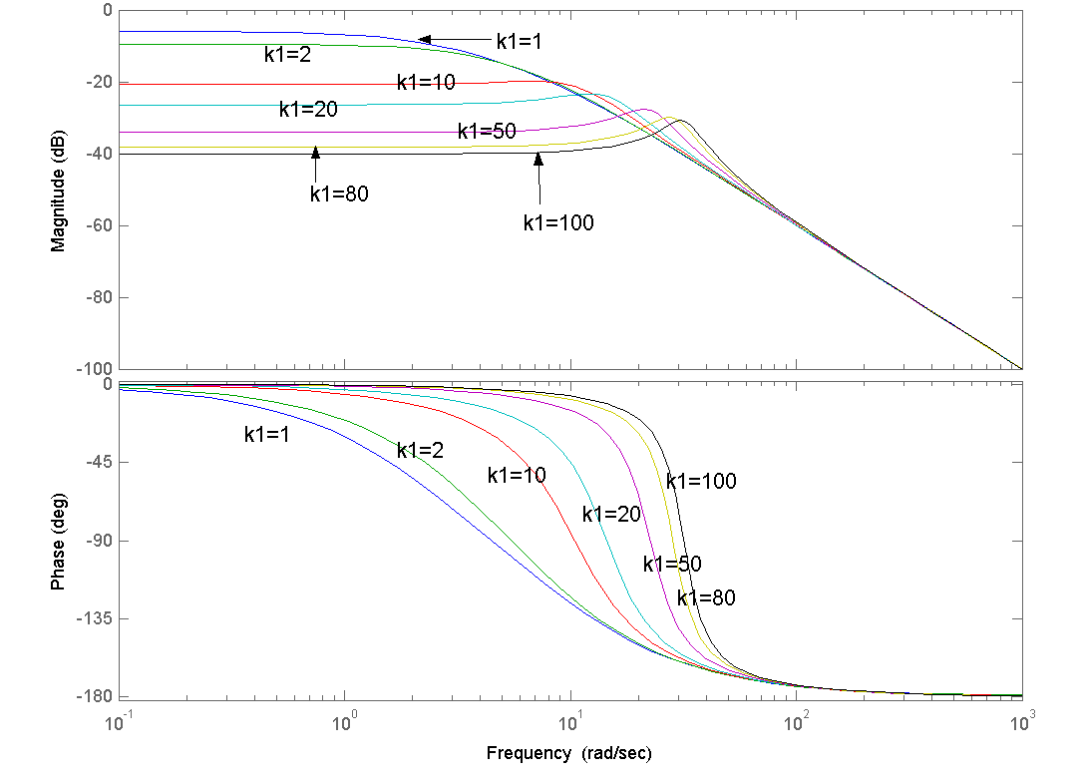
Graph 2: Step response for values of k₁=(1,2,10,20,50,80,100)
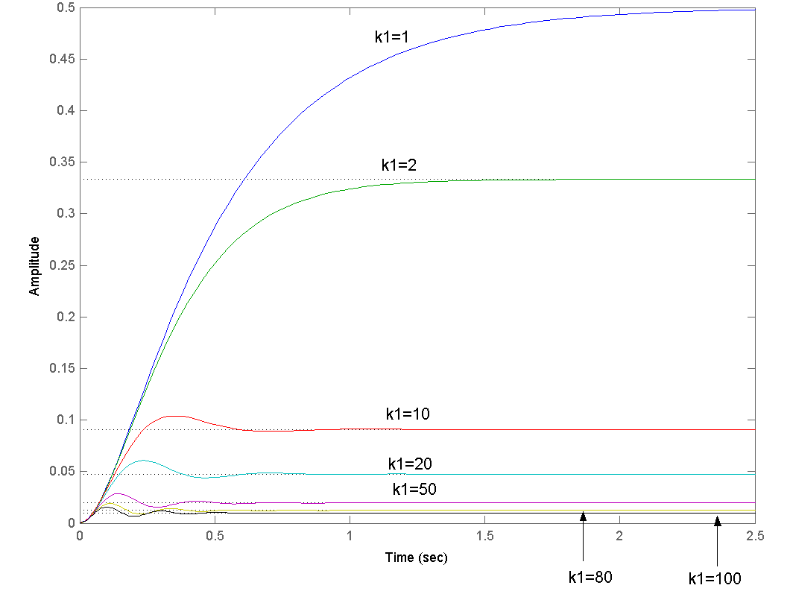
Graph 3: Bode plot of a single peak at 5Hz( k₁=100)

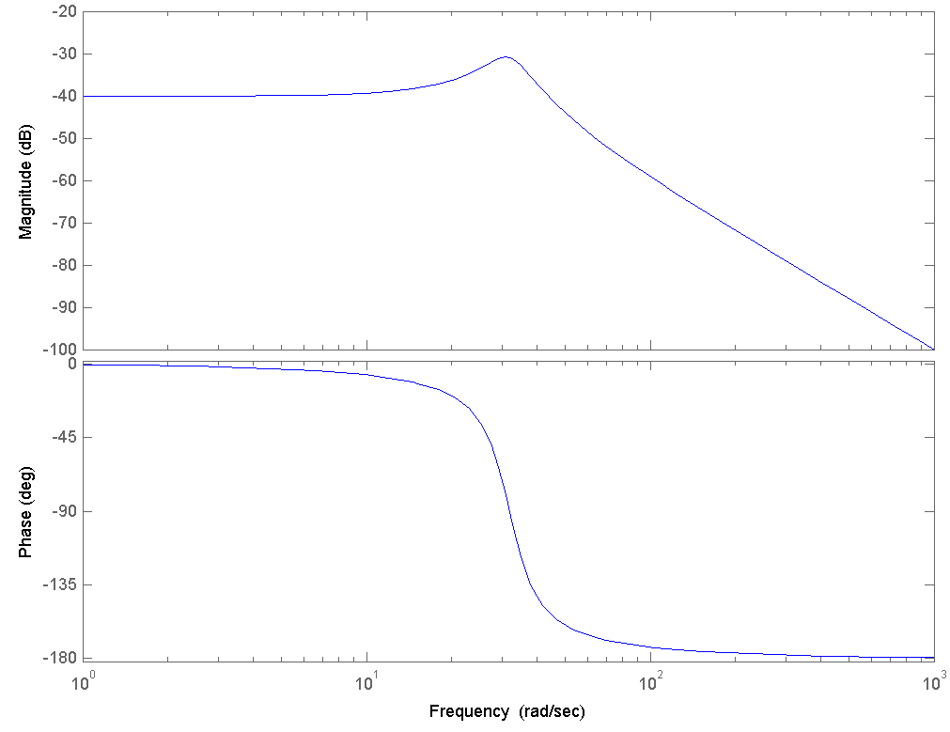
Graph 4: Step response diagram when k₁=100
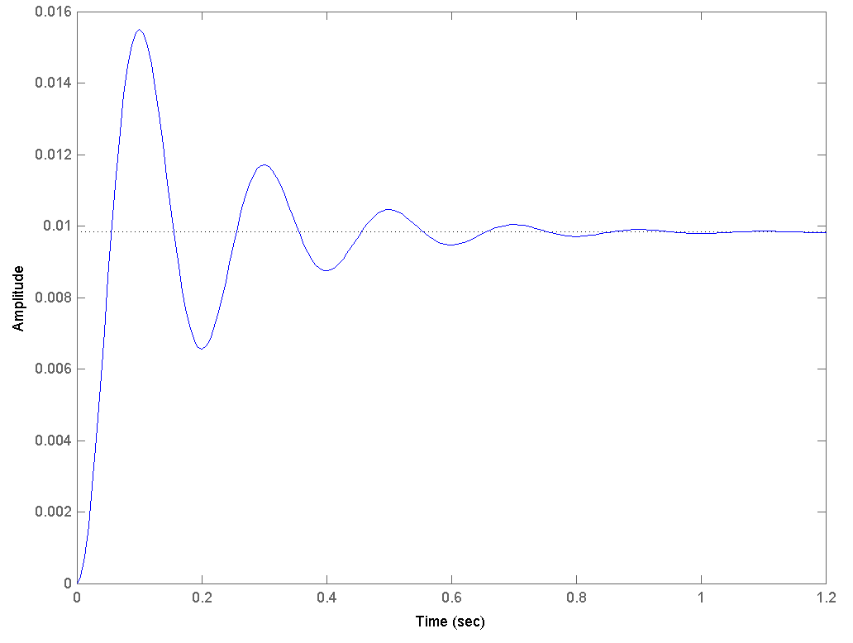
Graph 5: Step response when k₁=100 and k₂=(1,2,3,4,5)
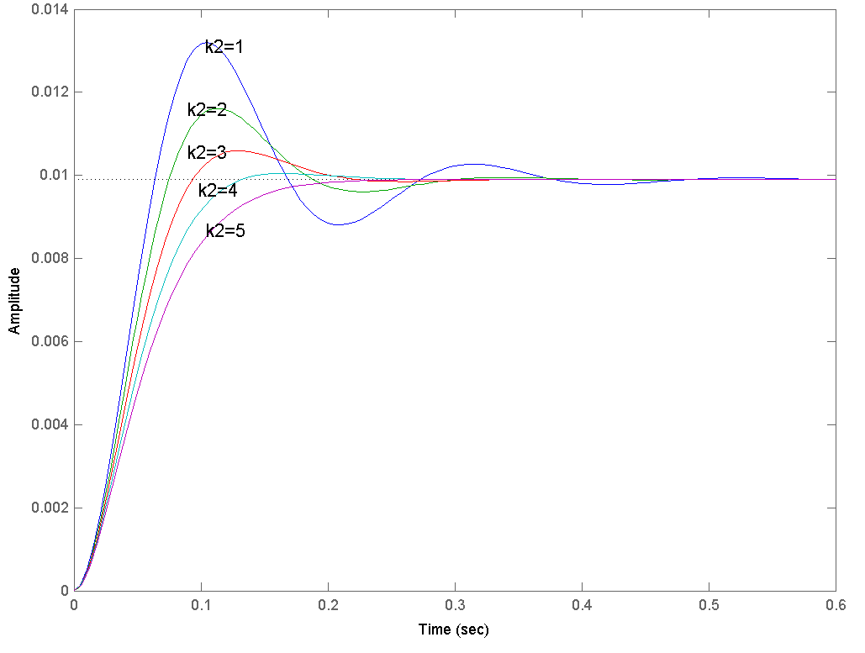
Figure 1: Poles and zeros diagram for k₁=100 and k₂=(1,2,3,4,5)
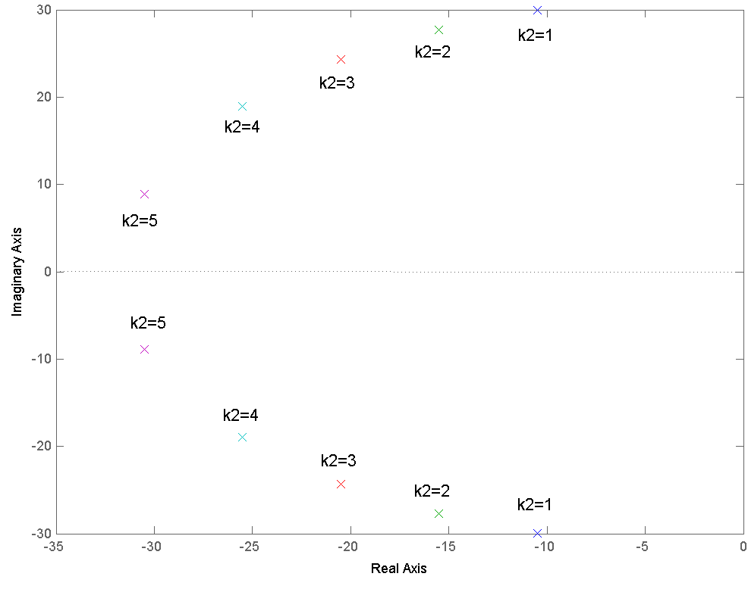
Graph 6: Bode diagram when k₁=400 and the peak is at 62.8rad/sec

